[Article Title] Manuscript preparation instructions for the CETRA 2020 proceedings
[Authors] First¹, Second², Third¹ & Fourth Author²
[Authors' Organisation & Country] ¹ First and third authors' Organisation, Country
² Second and Fourth authors' Organisation, Country
[Numberless Heading] Abstract
[Normal] Manuscript preparation for CETRA 2020 proceedings is a fairly simplified process. Everything you need for a properly formatted article is contained in this template document, which uses a feature of Microsoft Word called Styles. A style is a set of formatting characteristics that you can apply to text in your document to quickly change its appearance. When you apply a style, you apply a whole group of formats in one simple step. For example, you may want to format the sections headers to make them stand out. Instead of changing the headings one by one, you can give them a style and change them all at once. All the styles in this document are preformatted so you only need to pick an appropriate one for the part you are working on. In this example document, each section that uses a specific style starts with a style name surrounded by square brackets for easy identification. The text you are reading at the moment is formatted using [Normal] style, whilst the heading above it uses [Numberless Heading] style and so on. These words serve only as a reference and should be omitted in the paper you submit.
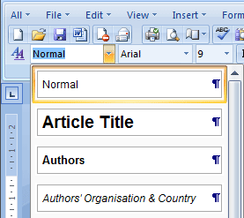
- Styles dialogue in Microsoft Word 97-2003
[Normal] Depending on the version of Microsoft Word you are using, you can access styles in one of two ways. Word 97-2003 features styles as a part of standard formatting toolbar, just left to where you usually choose the font you wish to use. This case is shown in Figure 1. Word 2007 to 2016 and Office 365 users will find 'Styles' group on the Office ribbon under the 'Home' tab, as shown in Figure 2. This group may be expanded to a list by clicking on the icon in its lower-right corner which will open a window similar to the one in Figure 3.
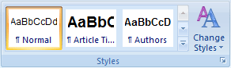
- Styles group in Microsoft Word 2007 - 2016
[Normal] The process of applying styles to text is simple: just position the cursor in the block of text you wish to style and pick an appropriate style name from the list mentioned in the preceding paragraph. In many cases this will not be necessary as this template is programmed in a way that it tries to 'guess' the correct style based on the flow of text.
- Styles list window in Microsoft Word 2007 – 2016 and Office 365
[Normal] Do not change formatting settings for any of the styles. Do not change predefined fonts unless necessary (e.g. in formulas or tables). In this case, please be sure to embed/include any and all non-predefined fonts along with your paper.
[Normal] Template uses a page sized 165 × 235 mm. Do not change the dimensions nor the margin sizes of the page. Do not use headers, footers, or page numbers in the paper. The area in which you are to key your text is 115 mm × 180 mm. All text, figures and tables must be set within this area. All text should be produced as a single column and justified throughout. These properties are already set in the [Normal] style. The first page must contain the title of the paper, the authors’ names, organisation and country, the abstract, keywords, and the first part of the paper. In the title of the article only the first letter of the first word should be capital (unless proper nouns are used) while the rest must all be lower case letters. Following the title should be authors’ names, without degrees or qualifications. After that, on a new line, authors’ organisation and country only (you may add the name of your department). Now start the abstract with a heading 'Abstract' and then the text of the abstract. The abstract should consist of approximately 300 words. It must not run over onto the next page.
[Keywords] Keywords: tram, track, vibrations, urban areas, analysis
[Normal] The Keyword heading together with the chosen words should appear on a new line immediately following the last line of the abstract. It is recommended to use five keywords that best describe the unique content of your paper as in the example above.
- [First Level Heading] Introduction
[Normal] Neither first nor the following paragraphs of any given section should be indented.The rest of this paragraph is filled with meaningless placeholder text. Nullania nullabo. Debisquae mollore nossitati res dolectia quo moluptatas repera aspelenim dolupta tendiatur solore ma pro es autestem ut vel ipitaquibusa nobisci totatqui od everio omnient officipsam exped mo inciur auta vendent pos asperro beriore henihitat dolestiis por at..
  - [Second Level Heading] Second level heading
[Normal] Neither first nor the following paragraphs of any given section should be indented.The rest of this paragraph is filled with meaningless placeholder text. Nullania nullabo. Debisquae mollore nossitati res dolectia quo moluptatas repera aspelenim dolupta at..
    - [Third Level Heading] Third level heading
[Normal] Neither first nor the following paragraphs of any given section should be indented.The rest of this paragraph is filled with meaningless placeholder text. Nullania nullabo. Debisquae mollore nossitati res dolectia quo moluptatas repera aspelenim dolupta officipsam exped mo inciur auta vendent pos asperro beriore henihitat dolestiis por at..
- [First Level Heading] Mathematical formulas, figures, tables
  - [Second Level Heading] Mathematical formulas and equations
[Normal] All equations must be clearly set. When referring to equations in the text, preface the number with the word ‘eqn’ or ‘eqns’ and place the number within brackets i.e. eqn (1). Displayed equations should be numbered simply (1), (2), etc. Do not set them in bold type. Please ensure that subscripts and superscripts are clearly legible. Equations should be placed in separate paragraphs using style [Formula] in such a manner that the equation is preceded and followed by a tab character: this will centre the equation and align the equation number to the right like in the following example:
(1)
  - [Second Level Heading] Figures, photographs, illustrations, diagrams
[Normal] Figures, photographs, illustrations, diagrams, maps etc., must be integrated within the electronic file and positioned in the correct part of the page. If you have original drawings or photographs you must scan them and place them in the file. Photos, figures etc. should be aligned left and positioned close to their text reference. They should not appear on the opening page (first page) or after the references and must fit within the page text area. All illustrations should be captioned using style [Figure caption]. Numbering of figure captions is automatic and sequential starting with number 1.
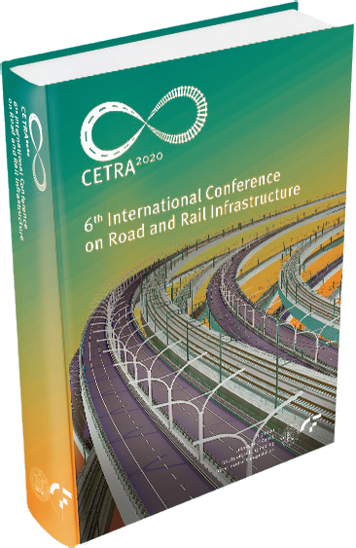
- [Figure] CETRA 2020 Book of Proceedings
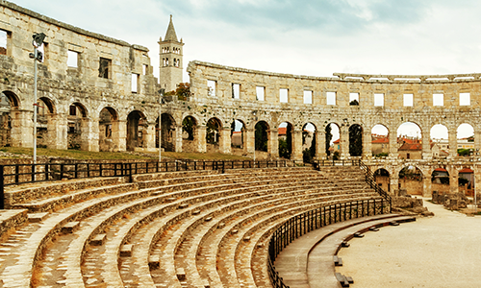
- [Figure caption] This is an example for a caption longer than one line of text. The figure represents roman amphitheatre in Pula, venue for CETRA 2020
  - [Second Level Heading] Tables
[Normal] Tables must be set as part of the text, but smaller font sizes may be used, providing they are clearly legible, to enable the table to fit the space. Table content can be formatted using a style [Table]. All tables should be centred on the page and must have a caption placed above the table using the style [Table caption]. Large tables may be set landscape, i.e. sideways on the page, reading up. Numbering of table captions is automatic and sequential starting with number 1.

- [Table caption] Measuring results
[Table] Mode of vibration | Experimental frequencies [Hz] | Numerical frequencies [Hz]
1 | 10.4 | 12.1
2 | 10.5 | 12.1
3 | 11.7 | 12.3
  - [Second Level Heading] Cross-ref's (equations, figures, tables, etc)
[Normal] When referring to equations enclose the numbers in parentheses and precede them with “Eq.” or “Eqs.”. Put an unbreakable space between “Eq.” and the number. For example, you can refer to Eq. (1). When referring to figures, precede the number with “Fig.”. Put an unbreakable space between “Fig.” and the number. For example, you can refer to Fig. 1.
[Normal] When referring to tables, precede the number with the word “Table”. Put an unbreakable space between “Table” and the number. For example, you can refer to Table 1.
[Normal] When referring to sections, subsections and subsubsections precede the number with the word “Section”. Put an unbreakable space between “Section” and the number. For example, you can refer to Section 2. Moreover, you can also refer to Section 3.2.2.
- Other important information
[Normal] Your manuscript will have an attractive layout if you follow the style-related instructions given above. There are several other instructions that should be carefully followed.
  - [Second Level Heading] Page numbering
[Normal] The manuscript should not exceed the maximum of eight (8) pages. There is only one exception to the above rule: keynote papers may be up to sixteen (16) pages long. The CETRA 2020 Organising Committee has the right to reject papers considered inappropriate for the proceedings, even if the abstract originally appeared to be acceptable.
  - [Second Level Heading] Units
[Normal] The use of SI units is strongly recommended and mixed units are to be avoided.
  - [Second Level Heading] Photographs
[Normal] It is necessary that you reduce your photos and paste them in the text where you want them to appear. Use resolution of raster graphics between 200 and 300 dpi in order to be acceptable for press (you can use Compress pictures option in MS Word). Do not use ultra high resolution pictures since this will increase the size of your final DOC.
  - [Second Level Heading] Submission of papers
[Normal] All papers are advised to be received as a DOC/DOCX files no later than 30 March 2020.
[Normal] Papers must be produced electronically and be PC compatible. Also, papers must be prepared using the templates and submitted in their original file format as DOC/DOCX (MS Word) files. It is important that the grammar and spelling of your paper is correct. If English is not your first language, please have a native English speaker check your paper for you. When finished, double-check the whole paper thoroughly and ensure that all figures, captions, tables, equations etc. are legible, as these often present problems.
[Normal] To submit the paper you will have to log in to the Conference website at https://www.grad.unizg.hr/cetra with your credentials and find your abstract under "Active Submissions" and press the link "AWAITING UPLOAD". This link will take you to the upload page. No specific file name is required (i.e. authorname.docx is satisfactory). When uploading a file, the name will be automatically changed to the following format ID-N-V-SM.docx where ID stands for the paper ID, N is number of a file in the database, V is the version of the file that will change if there will be some revisions and SM that stands submitted version. Please ensure that the DOC file is 15 MB or smaller. In case of any problems during submitting your paper using on-line submission system, do not hesitate to contact the Conference Secretariat at: cetra@grad.hr.
Detailed instructions for paper submission can be found at:

https://www.grad.hr/cetra/ocs/index.php/cetra6/cetra2020/schedConf/cfp
[Numberless Heading] References
[Normal] The reference heading should NOT be numbered. References should be styled as [Reference]. An example of the proper format for references is given below. The title of the journal, book or conference proceedings should be in italics. For citations in the text please use square brackets and numbers: [1], [2]. The first citation in the text should correspond with the first name on the reference list.
[Normal] References should be collected at the end of the paper and set in the following order: Author surname, initials, title, publication, volume, page range, year. Refer to the examples included with these instructions. Numbering of references is automatic and sequential starting with number 1. Do check your final paper to ensure that references within the text correspond to the reference list at the end. The references given below are examples of the following: (1) paper in a journal; (2) paper in a journal with DOI; (3) book; (4) chapter in a book; (5) paper in conference proceedings; (6) personal communication; (7) web site.
- [Reference] Popp, K., Kruse, H., Kaiser, I.: Vehicle-Track Dynamics in the Mid Frequency Range, Vehicle System Dynamics, 31, pp. 423-464, 1999.
- [Reference] Lazauskas, M., Kutut, V., Zavadskas, E.K.: Multicriteria assessment of unfinished construction projects, GRAĐEVINAR, 67 (2015) 4, pp. 319-328, doi: 10.14256/JCE.1179.2014
- [Reference] Esveld, C.: Modern Railway Track, Second edition, TU-Delft, 2001.
- [Reference] Ahac, M., Lakusic, S.: Track Gauge Degradation Modelling on Small Urban Rail Networks: Zagreb Tram System Case Study (Chapter), Urban Transport Systems, ed. Yaghoubi, H., InTech, Rijeka, pp. 1-20, 2017.
- [Reference] Hartmann, T.: Virtual Management of Complex Infrastructure: Information Systems in the Age of BIG DATA, 4th International Conference on Road and Rail Infrastructure - CETRA 2016, pp. 21-36, Šibenik, Croatia, 23-25 May 2016.
- [Reference] Person, A. Personal communication, 20 November 2008, Position of Person in Company, Name of Company or University, City, Country.
- [Reference] Rubberized Concrete Noise Barriers (RUCONBAR), www.ruconbar.com, dd.mm.yyyy.

